How to Register Online for DMPS
Many of you are aware that Des Moines Public Schools has moved to an online registration process. It is imperative to individual school funding that this process is completed for each student prior to September 27, 2016. Here at Studebaker we are at risk of losing two teaching positions and significant funding for student materials if this process is not completed by September 27, 2016. Please follow the instructions below to complete online registration. If you need any assistance during this process please contact Kathy or Brian at Studebaker (515-242-8436) and we will help with this process. Please know that it is new to us as well but we will work with central office to solve any issues that arise.
Thank you for your prompt attention to this.
- Go to www.DMSchools.org
- Go to the parents tab in the middle of the page and open it.
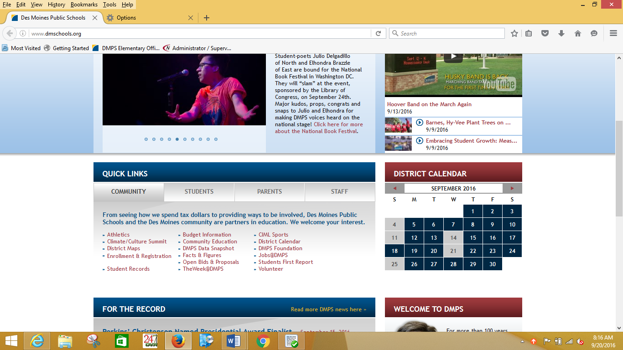
- Then click on Infinite Campus in the Parents tab.
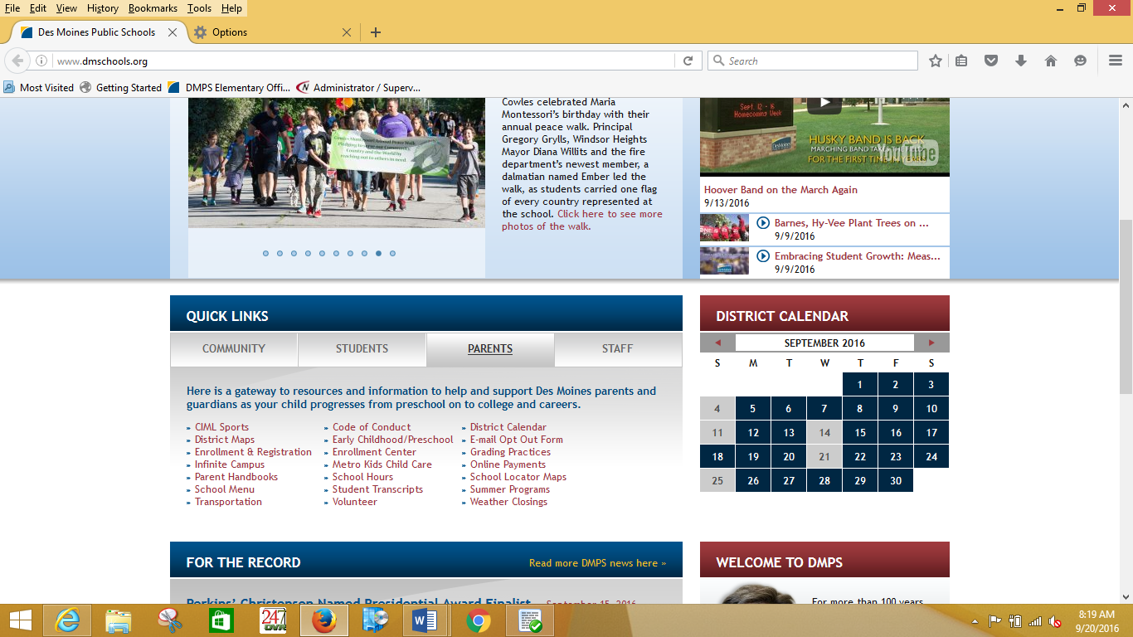
- Then click on the green Infinite Campus box.
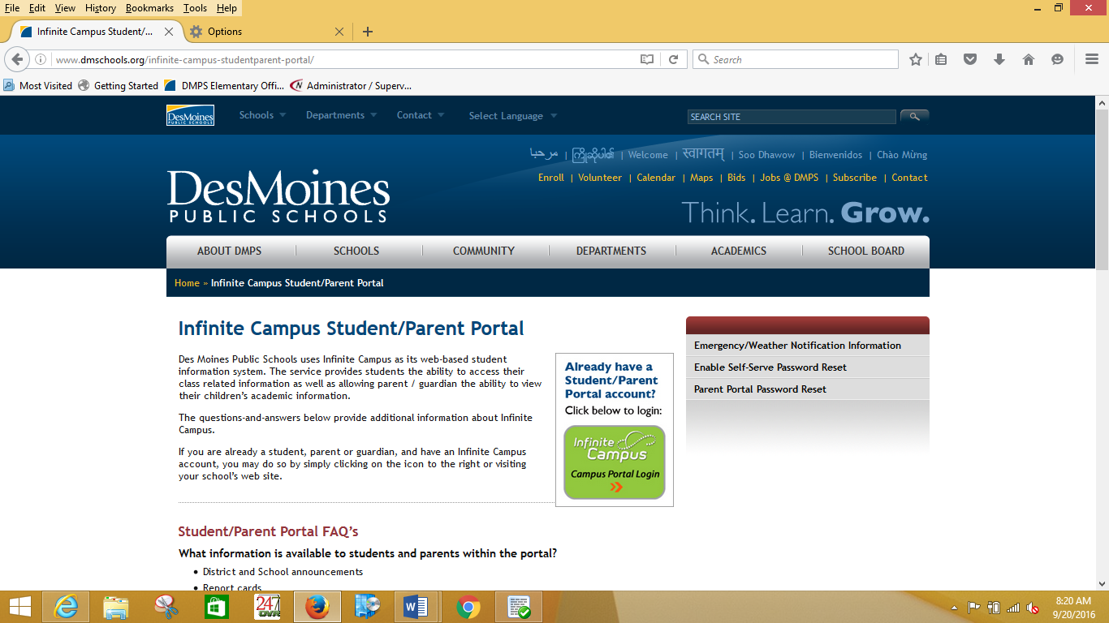

- Enter your username and password. (If you cannot remember your username and/or password please contact the school (Studebaker 515-242-8436) and we will assist.
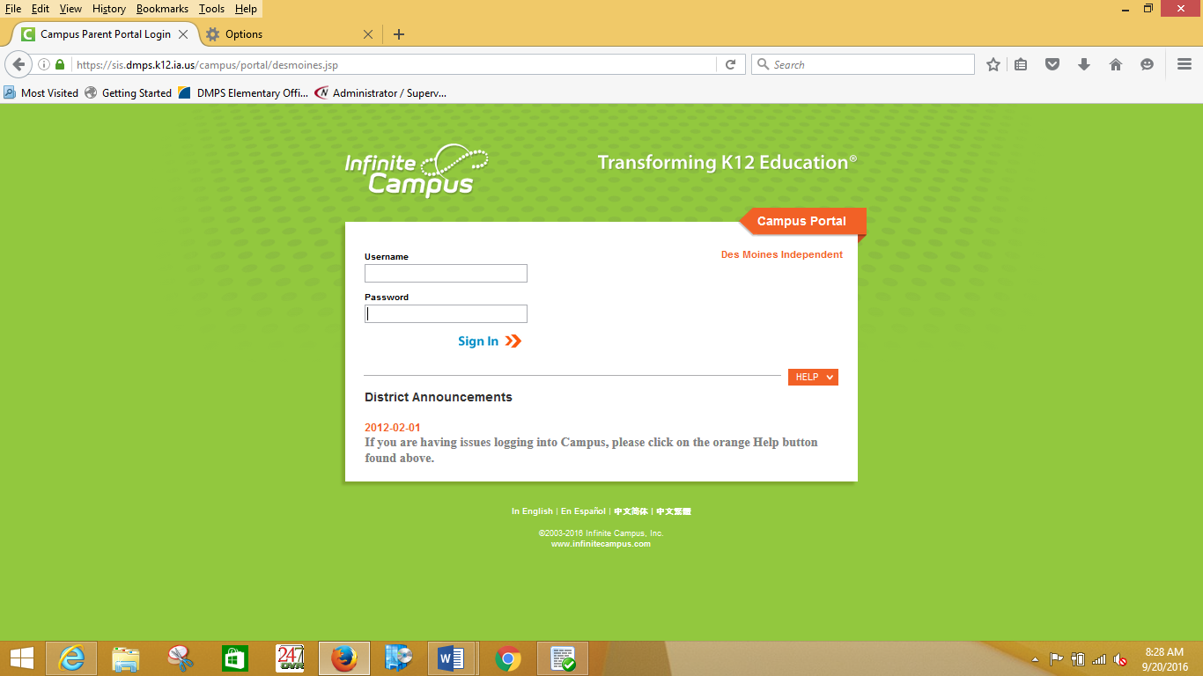

- Locate the email from July 5, 2016 entitled “Please click the link to begin the annual registration for the 16-17 school year.”
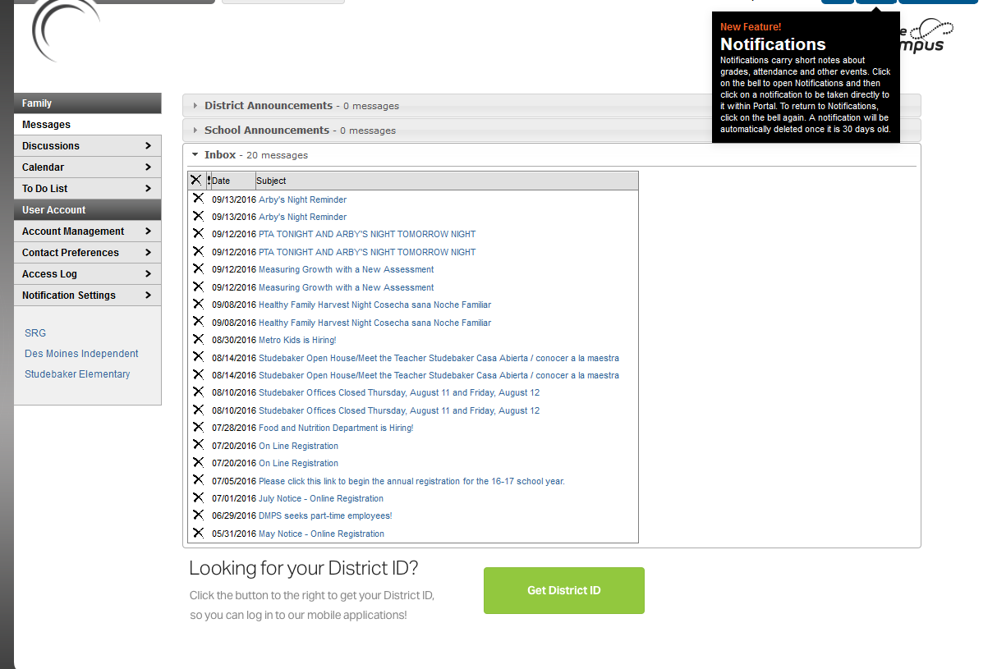

***If the email is not in your inbox please check back in two hours as Infinite Campus needs time to update your email inbox.

***If the email does not appear in your inbox after two hours please contact the school for assistance.

- If the email did show up please open it and begin the registration process.

If you need assistance anytime throughout the process please do not hesitate to contact Studebaker (515-242-8436).
Thank you for completing this process.

